Practical – 5

Registration Form with Frontend Validation and User-Friendly Error Handling
Problem Definition : Create a student registration form with HTML5 input types and JavaScript validation for name, email, mobile number, password, confirm password, course, year, gender, and terms acceptance. Use Regular Expression for validations.
A. THEORY
1. Are correct input types and attributes used?
Yes. Appropriate input types such as text, email, tel, and password are used. Attributes like required are also used to make the form more reliable.
2. Are validation errors displayed near the relevant fields?
Yes. Validation messages are displayed near the related input field so that users can easily understand and correct their mistakes.
3. Is password strength checked?
Yes. The password is checked using validation rules such as minimum length and a combination of letters, numbers, or special characters.
4. Is the form accessible using keyboard and screen-reader-friendly labels?
Yes. Proper <label> elements are provided for form fields, and the form can be operated using the keyboard. This makes it more accessible for users, including those using screen readers.

References
- MDN Web Docs – HTML Input Element
- MDN Web Docs – Client-side Form Validation
- MDN Web Docs – Label Element
- W3C – Forms Tutorial

B. Implementation/ Output/Result


C. Evidence of Work (Screenshots)
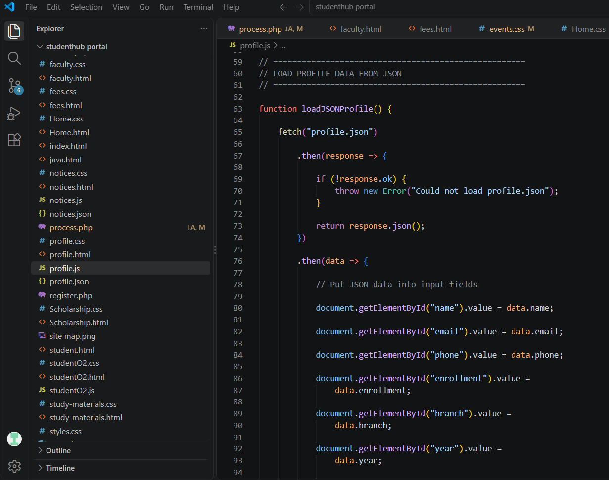
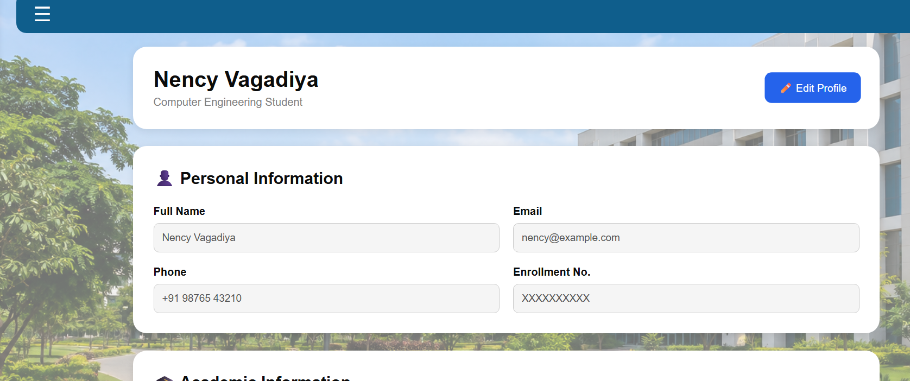

D. GitHub Repository Link
https://github.com/NencyNVagadiya/Student-Hub-portal/blob/main/profile.js

E. Challenges Faced:
I faced difficulty in validating different types of user inputs correctly. Each field required different validation rules, such as checking the name for only letters, validating the email format, checking the mobile number length, and ensuring that the password and confirm password matched. I also faced difficulty in creating and applying the correct Regular Expressions for each field.
F. Learning Outcomes:
Students will design accessible forms with robust client-side validation.

G. Faculty Remarks:

